**Introduction**

For my final assignment, I wanted to be able to take a piece of Ottawa and amplify it into a national historic lens to what was occurring in the country on a more grand scale, and how the events could potentially see a correlation with one another. My hopes were to be able to find some level of significant change in Ottawa that could be historically linked to the rest of Canada, allowing historians to be able to trace certain historical happenings. For this case study, I chose to focus on the Billings Family, as their presence in Ottawa is quite established, and the family is quite connected to a handful of historic sites and buildings within Ottawa. Since the Billings Estate and Bytowne were the establishing and growing communities in Ottawa, I figured the data pertaining to the family would be one that could help guide the construction of Ottawa as Canada’s Capital. With the pandemic limiting access to places such as the Billings Estate or National Libraries of Canada, this GLAM notebook would be able to provide further insight to these resources, allowing historians to be able to critically make connections and investigate the data further from their home.

**Datasets and Organization**

The dataset I chose to use and illustrate in several ways was the timeline that was included in the Billings Estate historical document, which illustrates events that pertain to the Billings family alongside events that synonymously occurred in Ottawa’s region surrounding events such as the establishment of Parliament. In this sense, we could further look at how events in Ottawa could relate to a National event occurring in the years following, or perhaps the other way around in order to see how historic events have played out or possibly influence one another. This data was translated to a CSV file in order to upload it in order for the notebook to digest and manipulate the data, Below is the initial importing of the data to outline its length and complexion impression:

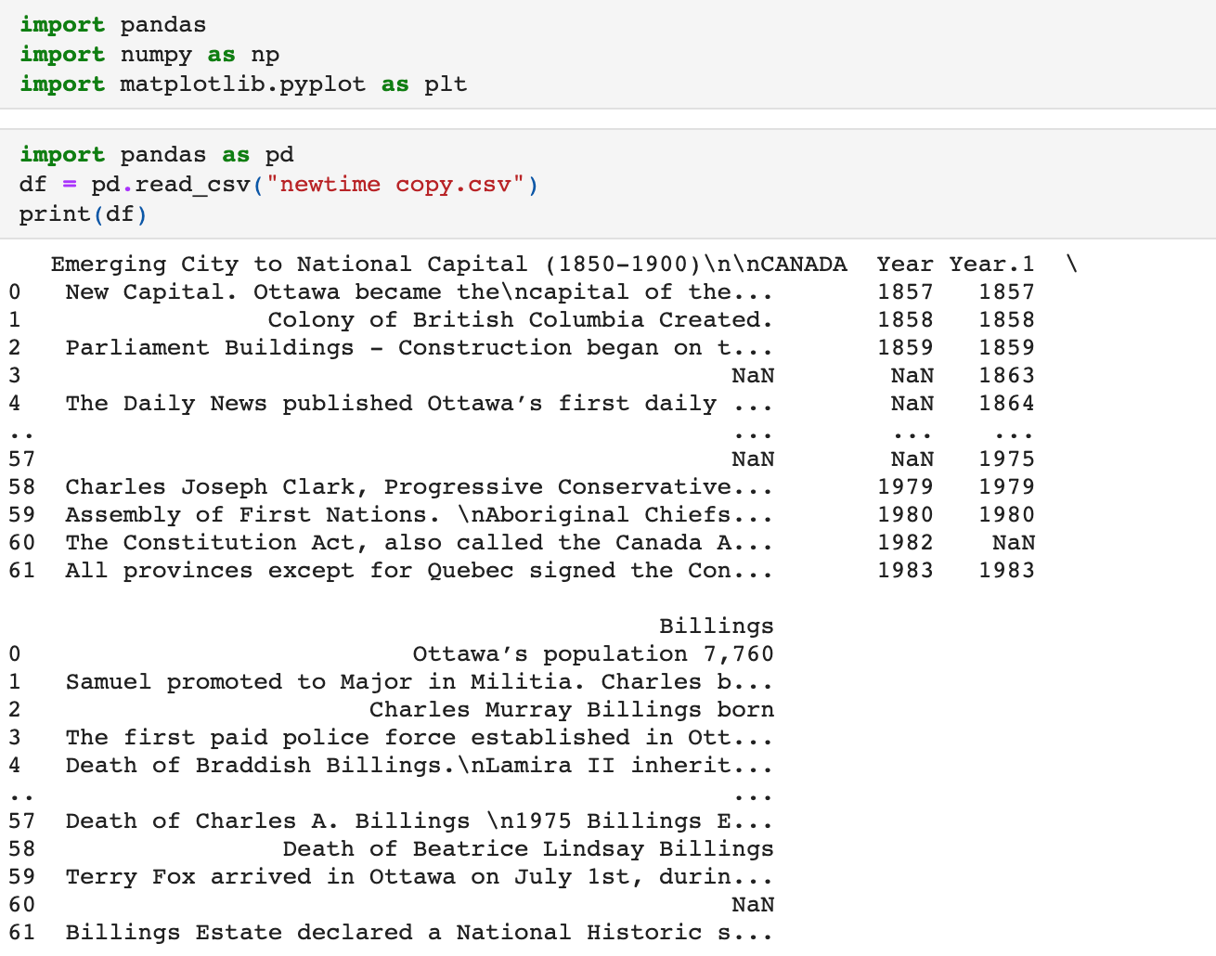

Though the dataset was not entirely organized, it was able to illustrate a fraction of events with years that outlined when it was occurring. However, there is not much we could draw from this table without it being condensed and focused on events on a case-by-case basis. From this dataset, a historian could focus on correlated events anywhere ranging from 1793-2005. However, for this specific notebook, the decades of 1850-1950 were included in illustrating events and data, as these events could be familiar with more of a general public audience, regardless whether the reader was educated on historical matters within Ottawa or Canada.

However, the initial attempt to organize the dataset did the opposite, and displayed the dataset in its entirety. This further complicates the dataset upon first glance to the reader, however it shows the great extent of the dataset and what the reader can further do with the dataset. Below is a preview of the lengthy illustration of the data after coding the initial labels for the table.

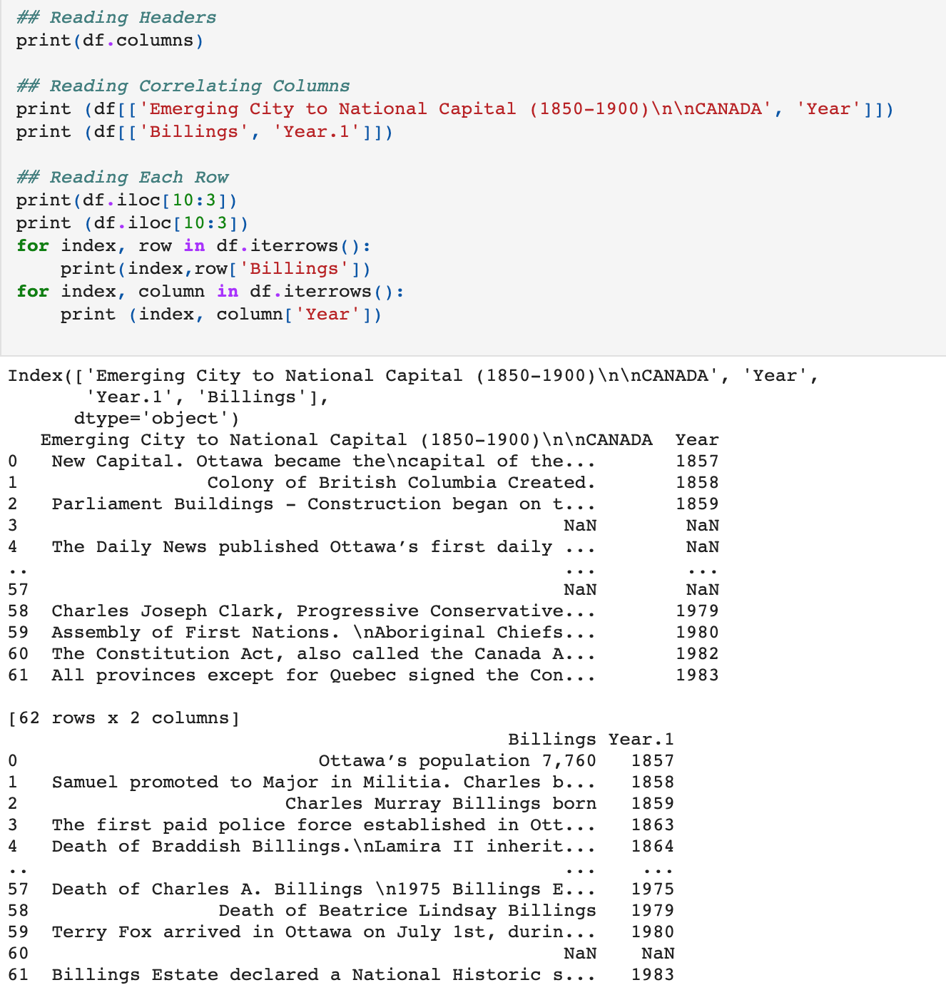

Further, the tables were coded and allowed the dataset to be succinct.

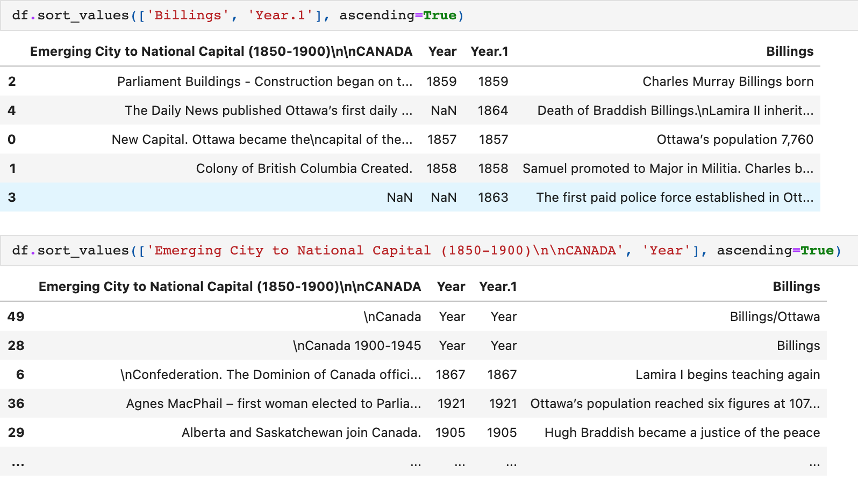

**Graphing**

To find another way to illustrate the data, the table was illustrated on a plot graph with the x-axis representing the years that coincide with the events in Canada and the y-axis representing the years where events happened in Ottawa. With both these graphs, we are to see where there is no data for the country or the city, the plot exists on one line and not on another. This can be attributed to where no other events were happening, therefore the plot is isolated on the graph. At first glance, it can appear that since the year on the y-axis does not reach the height of the year on the x-axis. However, with nothing significant happening in either Ottawa or Canada, there was no reason to illustrate the year. In this sense, the reader can infer that the isolated events could provide further context to the state of either the city or the country, and further research ways in which these events are able to relate to Ottawa’s development and growth into the places that are familiar to us today.

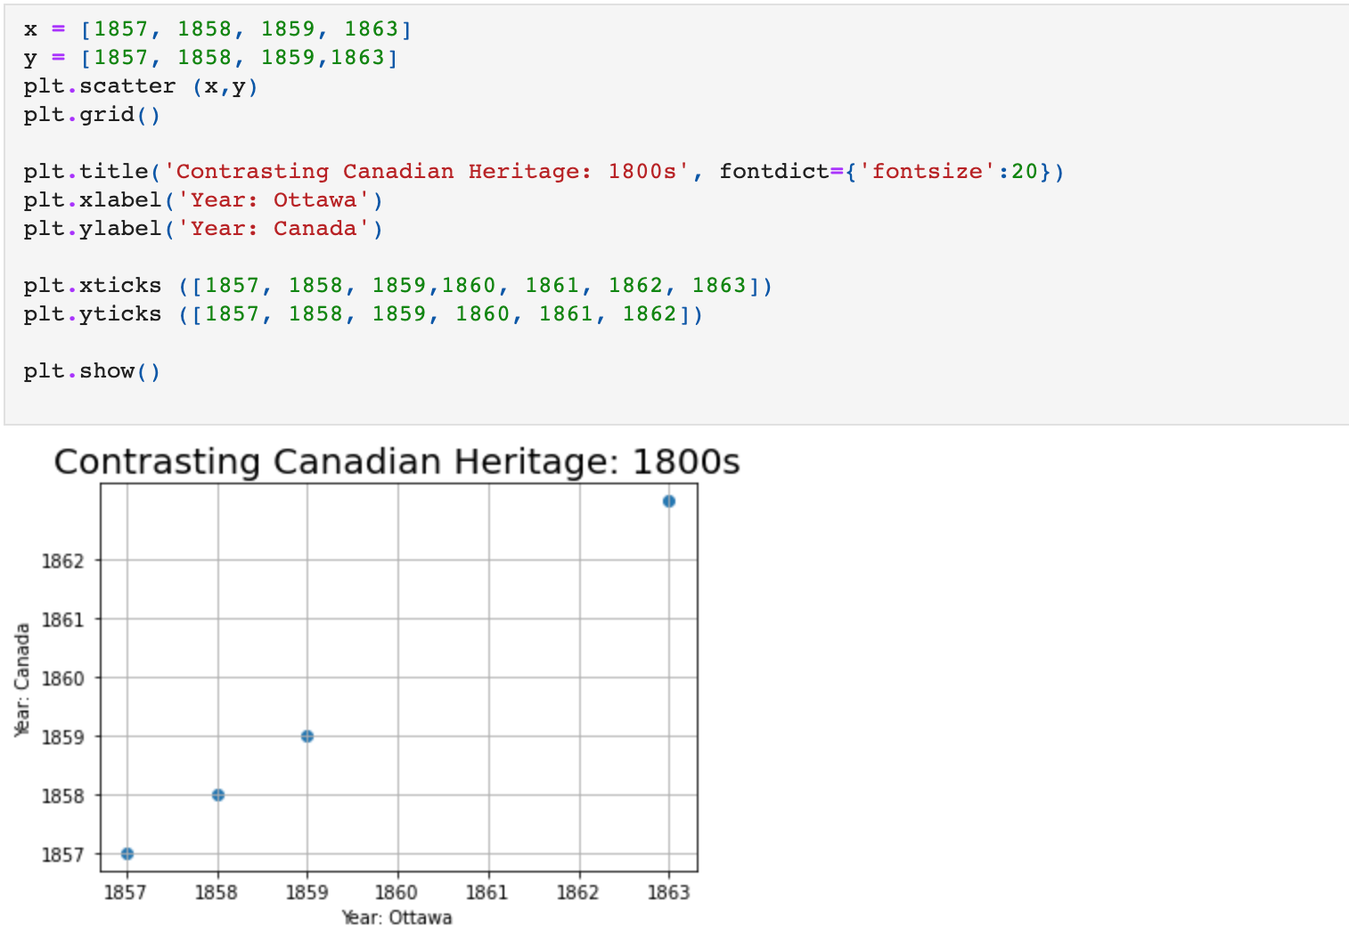

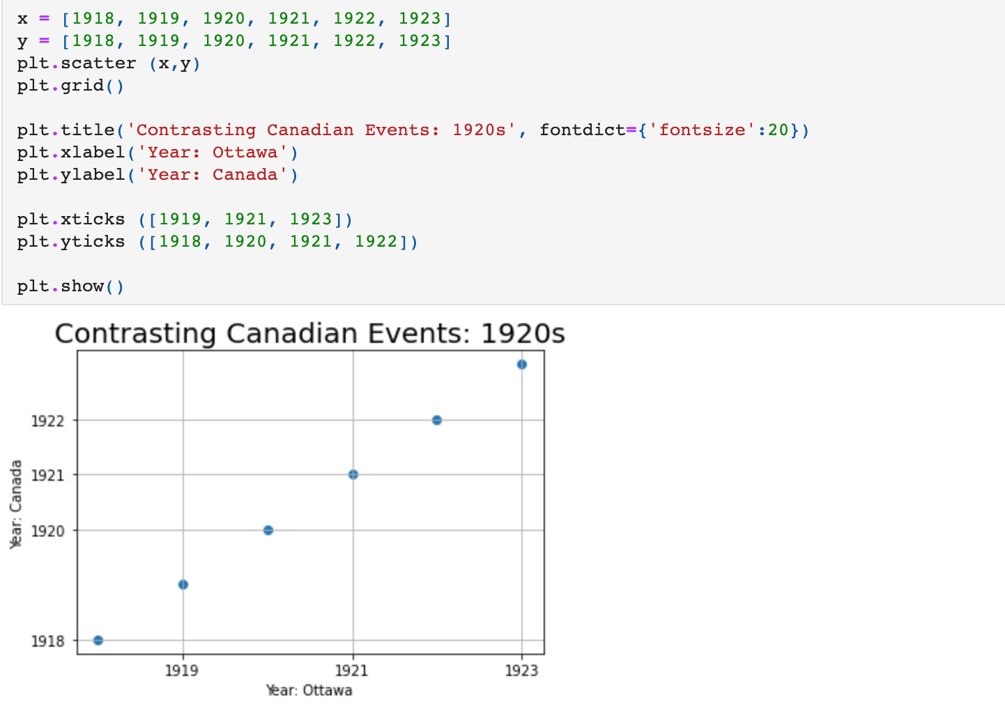

From these, we can see the slope gradually increasing showing the passage of time. In the last graph above, we can see that only one plot intersects while the other shows only one isolated historical event. We can see how certain events line up with each other, and perhaps reflect the significance of each other. These graphs can therefore lead historians research into further specifics about the correlation of these events, such as investigating further communities or notions that existed during the time that the events took place.

**Conclusion**

With the data displayed in the notebook, it does not provide the reader with conclusions, but rather opportunities to embark on further research and outline the correlation between events that helped establish Ottawa in its significance to Canada, and how Canada and Ottawa both further operated seldom of each other. In hindsight, the data could be cleaned up much more and allowed for other sets of data to interact with it in order to outline strong connections between the two events. However, the notebook still stands as an approach to understanding Ottawa’s construction as the capital as well as Canada as a whole. The Billings family plays a significant role as they are a part of the construction of Ottawa as a city, and therefore play a role in symbolizing the middle class within Ottawa, allowing it to grow and develop throughout the city. Though the research shows a snapshot of history within Canada and Ottawa, we are further able to utilize this journal to develop more GLAM data that is based surrounding Canada, essentially being able to grow the sets of data that exist regarding Canadian data.

**References**

City of Ottawa. (2021). *The Billings Family Virtual Exhibit | City of Ottawa*. Ottawa. https://ottawa.ca/en/arts-heritage-and-events/city-ottawa-archives/exhibits-and-events/virtual-exhibits/billings-family-virtual-exhibit?fbclid=IwAR12GKYeetFLySyiyDmAPBpc0QjX26QHNqoDokYelBqr3IIQHtUW-45igWc

Graham, S. (2021, March 29). *Building Our Notebooks* [Slides]. Discord. https://discord.com/channels/795790604889751552/795790605334085650

Jeon, T. (2018, May 9). *Pandas Tutorial: Importing Data with read_csv*. DataCamp. https://www.datacamp.com/community/tutorials/pandas-read-csv?utm_source=adwords_ppc&utm_campaignid=898687156&utm_adgroupid=48947256715&utm_device=c&utm_keyword=&utm_matchtype=b&utm_network=g&utm_adpostion=&utm_creative=332602034343&utm_targetid=aud-392016246653:dsa-429603003980&utm_loc_interest_ms=&utm_loc_physical_ms=9000671&gclid=Cj0KCQjwyN-DBhCDARIsAFOELTmZjqIHGBvKaAcw90FPIqC5dU4GlmsgC8S_6FlBgT0Idv-ybQ4neooaAvZWEALw_wcB

Jupyter Notebooks. (n.d.). *Plot_from_CSV_data | jupyter notebooks gallery*. Notebooks.Community. Retrieved April 15, 2021, from https://notebook.community/mholtrop/Phys605/Python/Plotting/Plot_from_CSV_data

Keith Galli. (2018, October 26). *Complete Python Pandas Data Science Tutorial! (Reading CSV/Excel files, Sorting, Filtering, Groupby)* [Video]. YouTube. https://www.youtube.com/watch?v=vmEHCJofslg&ab_channel=KeithGalli

Project Jupyter. (2018). *Working with Files — JupyterLab 3.0.14 documentation*. Jupyter Lab. <https://jupyterlab.readthedocs.io/en/stable/user/files.html>

**Additional Readings**

Cleverdon, C. L., & Cook, R. (1950). *The Woman Suffrage Movement in Canada: Second Edition (Heritage)* (2nd ed.). University of Toronto Press, Scholarly Publishing.

Heritage Ottawa. (2020, March 7). *3. The Billings Estate House*. Heritage Ottawa. https://heritageottawa.org/50years/billings-estate-house

Hernandez-Read, E., & Johnson, D. (2020, August 3). *A Reconciliation Framework for Canadian Archives*. Librarianship.Ca. https://librarianship.ca/news/reconciliation-framework-archives/

National Library and Archives of Quebec. (2014, December 19). *BAnQ et Wikimédia : Une première collaboration GLAM au Canada*. BAnQ. https://blogues.banq.qc.ca/instantanes/2014/12/17/banq-et-wikimedia-une-premiere-collaboration-glam-au-canada/